**BF[2] Enrichment Key**

**Type in your score here 🡪 ____ out of 30 points possible**

1. (5 points) Ponder/Reflect Exercise – Reflect on what you have learned from this portion of the class. Examples of what you can do are: a brief outline of material covered, insights you gained from class or personal study, or items you feel that you need to follow up or work on. (3-5 sentences)

**Any thoughtful answer is sufficient.**

2. Do a complete ANOVA on cancer file (cancer.txt). Fit an ANOVA model that includes terms for gender (“f” or “m”), cancer type, and the interaction between gender and cancer type.

(a) (5 points) Find the complete ANOVA table USING TYPE I SS. Carry out the complete analysis considering the decision flow diagram discussed in class for two-way ANOVA. Give a complete interpretation for each of the terms in the model.

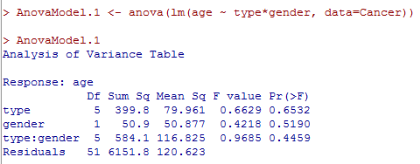

**The p-values are large for the main effects so we would NOT reject the null hypothesis; therefore, we say that we have insufficient evidence the means are different between gender as well as type of cancer.**

**The p-value for the interaction is large so we would NOT reject the null hypothesis; therefore, we say that that we have insufficient evidence that we have an interaction.**

(b) (5 points) Find the complete ANOVA table USING TYPE III SS. Carry out the complete analysis considering the decision flow diagram discussed in class for two-way ANOVA. Give a complete interpretation for each of the terms in the model.

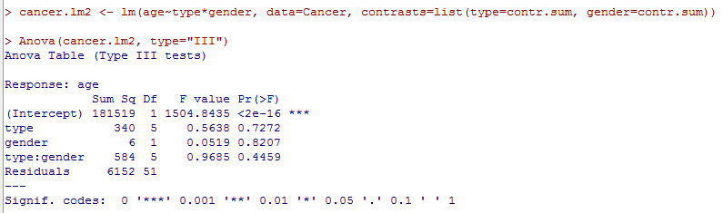

**The p-values are large for the main effects so we would NOT reject the null hypothesis; therefore, we say that we have insufficient evidence the means are different between gender as well as type of cancer.**

**The p-value for the interaction is large so we would NOT reject the null hypothesis; therefore, we say that that we have insufficient evidence that we have an interaction.**

3. Do a complete analysis of variance on heights of singers in a choir, found in the file singerheights.csv (note that it is comma-delimited). Fit an ANOVA model that includes terms for gender (“f” or “m”), singing part (“low” or “high”), and the interaction between gender and part. (Note that the low part for females is generally called alto, high part for females is soprano, low part for males is bass, and high part for males is tenor. However, we are interested in the association between singing the high/low part and height, so we are treating this as a 2 x 2 factorial instead of a one-way Anova with 4 levels of “singing part.”)

(a) (5 points) Find the complete ANOVA table USING TYPE I SS. Carry out the complete analysis considering the decision flow diagram discussed in class for two-way ANOVA. Give a complete interpretation for each of the terms in the model.

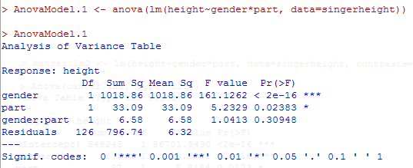

**The p-values are small for the main effects so we would reject the null hypothesis; therefore, we say that we have sufficient evidence the means are different between gender as well as part.**

**The p-value for the interaction is large so we would NOT reject the null hypothesis; therefore, we say that that we have insufficient evidence that we have an interaction**

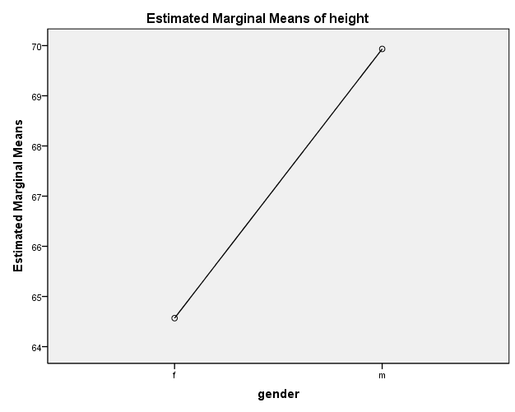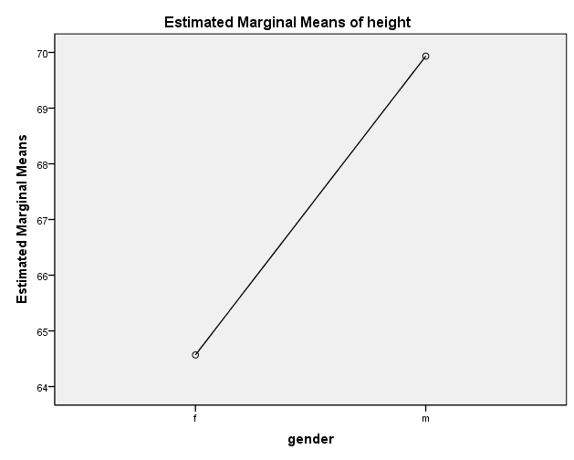

**Looking at means plots, Males are taller and low parts are taller as well.**

(b) (5 points) Find the complete ANOVA table USING TYPE III SS. Carry out the complete analysis considering the decision flow diagram discussed in class for two-way ANOVA. Give a complete interpretation for each of the terms in the model.

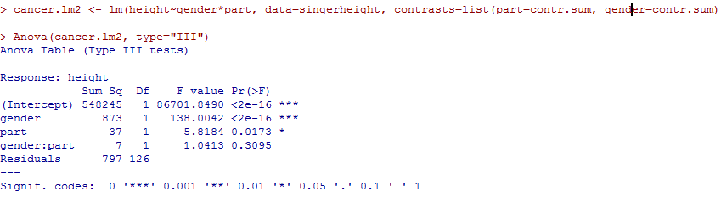

**The p-values are small for the main effects so we would reject the null hypothesis; therefore, we say that we have sufficient evidence the means are different between gender as well as part.**

**The p-value for the interaction is large so we would NOT reject the null hypothesis; therefore, we say that that we have insufficient evidence that we have an interaction**



**Looking at means plots, Males are taller and low parts are taller as well.**

(c) (2 points) Why is the SS for gender so much smaller with Type III SS? Explain.

**SS for gender for Type III SS is smaller because Type III SS puts all the other terms in the model, and what is left over is given to the gender SS. Whereas with Type I SS, it is the first term that is included in the model so there is more sum of squares to work with.**

4. (3 pts) What are the main reasons we want to use replication (more than one unit per treatment group)?

**Replication gives more precision to our estimate of model parameters. Also, replication gives us information about the error $ε_{ij}$ which then allows us to make inference about the model parameters**